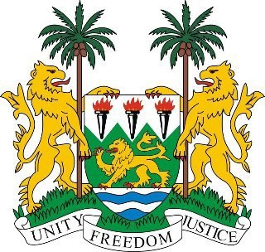
SIERRA LEONE
20th Session of the Universal Periodic Review

KAZAKHSTAN

30 October 2014

Mr President,

Sierra Leone welcomes the delegation of Kazakhstan and thanks them for the presentation of the national report.

My delegation notes with appreciation the ongoing efforts to meet its human rights obligations, as evidenced by its open collaboration with eight Special Rapporteurs and its consistent yearly contribution to the OHCHR since 2010. We commend the government for their almost universal enrolment at the primary and secondary education.

Sierra Leone would encourage Kazakhstan to promote gender inequality, eliminate structural inequalities and the occupational segregation of women. And in the same vein, comprehensively address the high incidence of domestic violence and combat sexual assault.

In addition, my delegation would urge the government to provide undocumented migrants and their children with access to essential medical care, education and public services.

Recommendations:

- Effectively address the issue of child marriage by encouraging girls to continue their education beyond the secondary level and establish laws which eliminate CEFM.
- Ratify ICRMW, and the second optional protocol to the ICCPR
- Put in place legislation which formally criminalises violence against women.
- Further promote policies and programmes which offer full and equal participation of all ethnic groups.

Sierra Leone wishes Kazakhstan a successful completion of this second review.

Thank you, Mr President.

